**Fissal Al Shref 212481285**

**3\31\2015**

**M.I …….. Second Project**

**Question #1**

**Plots represent the performance of breadth first search algorithm.**

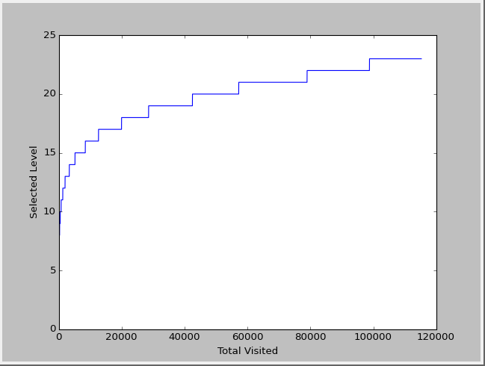

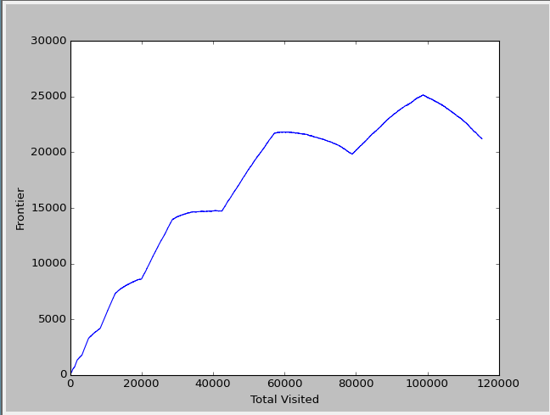

**Plots represent the performance of the depth first search algorithm.**

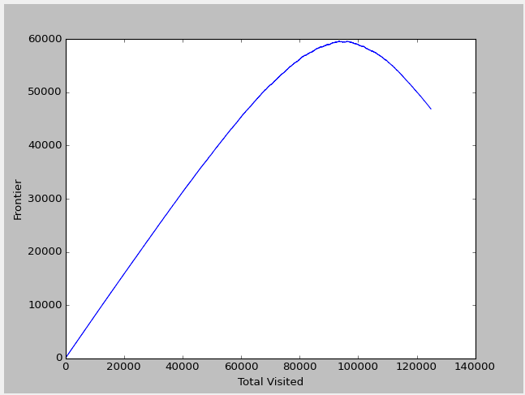

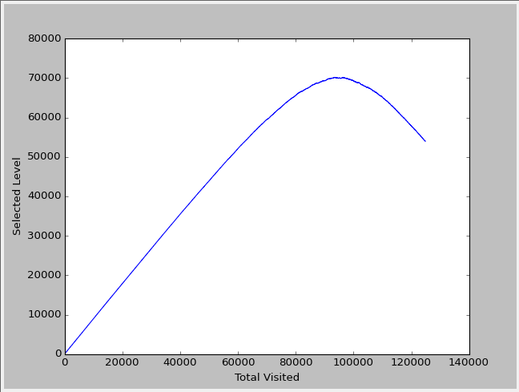

The number of the total visited node is changing between those algorithms where we can notice that the total visited node is equal to 115262 in breadth while it is about equal to 124837 in depth search one. The difference in the functionality within whose algorithms is the reason behind the distinguishing between the values of total visited nodes numbers. Breadth first search algorithm go through nodes and check them level by level while depth search algorithm go to the last child in the first branch it does have and jump to the next branch when it completes checking all the nodes hanging on that first branch and so on and so for. That as well will change the number of the frontier each algorithm will make.

**Question #2**

**Plots represent the performance of the A* search algorithm.**

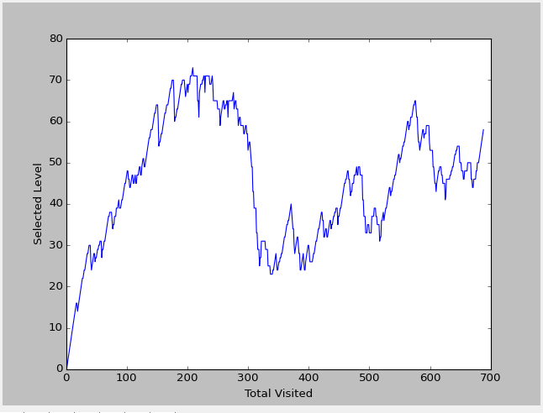

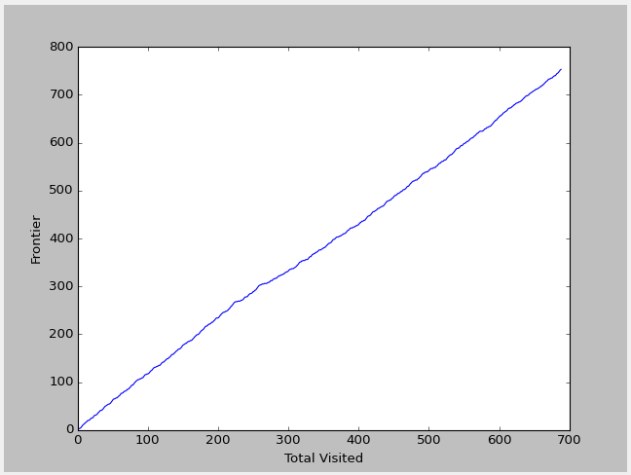

**A short explanation on how this algorithm works and the difference between the heuristic function.**

As we know that this algorithm which is called A* algorithm uses a function is called heuristic which increases the quality of A* algorithm’s performance. Heuristic function has two useful sub functions like h1 and h2 and we can any one of them in order to be able to solve a complicated problem. The sub function h1 counts the misplaced we have in the puzzle while h2 one counts the Manhattan distance. So that we can say that those two sub functions h1 and h2 are estimators, are used by A* A. to solve the puzzle problem. However, h2 is distinct of h1 in the estimating part where h2 is a very good estimator rather than h1.